Mind Candy Bowling

by Stephen Phillips

Contents

1 Introduction 1

2 User Experience 2

2.1 Splash Screen 2

2.2 Player Name Entry 2

2.3 The Scoreboard 4

2.4 Rules of Ten Pin bowling 5

2.5 Winning the Game 6

3 Unit Testing 7

# 1 Introduction

To use the Mind Candy Bowling scoreboard, simply run the "MindCandyBowling" executable file found in the Bin folder of this distribution. This program will run on any* Windows machine, and does not require prior installation.

Mind Candy Bowling is a simple command line program designed to record and display scores for a game of ten pin bowling for between one and six players, with each game running for ten frames.

* user experience may vary on systems older than Windows XP

# 2 User Experience

There are multiple screens in the Mind Candy Bowling program, and the following subsections describe their layout and features in the order that they appear to the user.

## 2.1 Splash Screen

When running the program, the first thing that will be visible is the splash screen. This consists of an ASCII logo and a message as shown below:

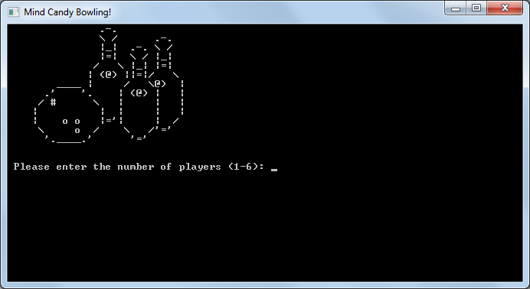

This prompts the user to choose the number of players that will participate in the game. Input will only be accepted in numerical format (i.e. '1', '2', etc. and not "One", "Two"…).

The console window will resize itself depending on the number of players chosen. The program then accepts a number of single-word names equal to the number of players entered at the splash screen.

## 2.2 Player Name Entry

The image below shows an example of the next screen, where a user has chosen four players for the game. This image also shows some sample names that are in the process of being entered:

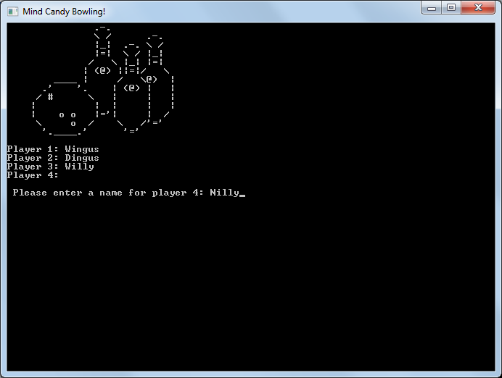

Please note that having spaces between words will denote multiple names being entered at once, so a two-player game with an input of "Alistair Norbert" would name the two players "Alistair" and "Norbert".

An entered name can be between three and sixteen characters in length. Also, each name is unique and cannot be entered multiple times. The program gives an appropriate message to explain these restrictions if an invalid name is entered.

For example, a player cannot be entered as "Me", as this is too short; likewise, "YellowDrippingMadness" is too long. Further, a player cannot enter the name "Alistair" if an existing player has already entered that name into the program.

## 2.3 The Scoreboard

When all participants have been assigned names, the main scoreboard is displayed as an empty table with the players listed in the order in which they were first entered. The program begins recording scores on the first frame for the first player. The current player’s turn is written below the scoreboard, and is also highlighted in yellow on the board itself [Windows only].

The program prompts the user to enter a single number – the number of pins that have been knocked down by the current player on their current shot.

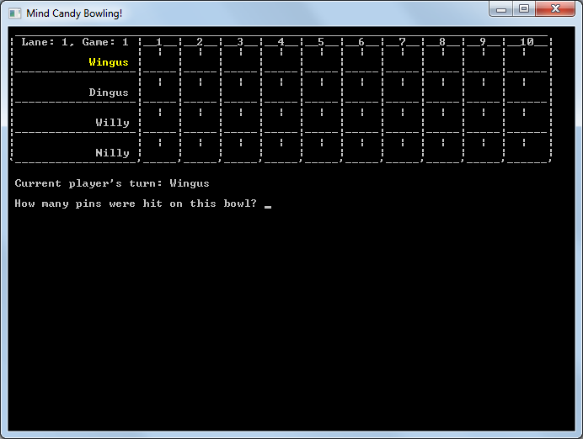

Each of the boxes on the scoreboard has three entries (four in the final frame); the number of pins hit by the first ball, the number of pins hit by the second ball, and the running total for the player. The final frame sometimes includes an extra shot, depending on the player’s outstanding bonus points. The program will only accept valid score inputs.

For example, the first shot of a frame can knock down anywhere between zero and ten pins. The second shot, however, can only knock down as many pins as are remaining; if the first shot scored four points, the second shot can only score up to six more points. Any invalid entries will be quietly ignored by the program, allowing the user to try again to enter a correct value.

When a player finishes all of their shots for a frame, the scoreboard is updated and the next player takes their turn. Some of the running total values may be left blank if the player still has bonuses left outstanding from previous shots.

## 2.4 Rules of Ten Pin bowling

The Mind Candy Bowling program incorporates all of the rules of Ten Pin bowling. This covers the basic rules described above, as well as awarding bonus points for players that manage to get Strikes or Spares.

A Strike occurs when a player knocks down all ten pins with their first ball in a frame. With the sole exception of the final frame, the player’s turn then finishes without a second shot. The player is awarded the full ten points, but also gains bonus points equal to the total scored by their next two shots.

A Spare occurs when a player knocks down all ten pins with two shots in a frame. In a similar fashion to a Strike, the player is awarded the full ten points, but also gains bonus points equal to the total scored by their single next shot.

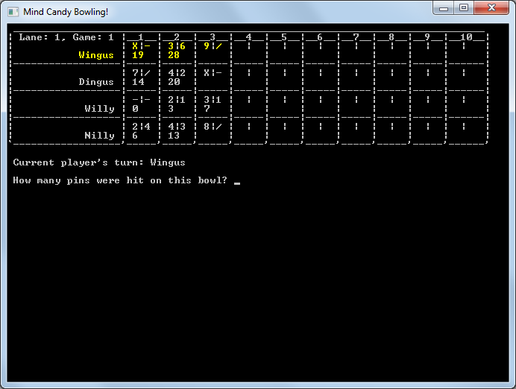

In the example screen shown here, there are three scores with blank values in their running totals. This is because there have been two Spares and a Strike in the last frame, all of which are subject to bonus points. In this example, if Wingus were to knock down four pins with his first ball and two pins with his second, he would have a total score of 48 (his current total of 28, plus 10 for his last frame, plus his bonus of 4 for the first shot, and finally 6 for his score in this frame). This would be represented in his score as 42 in his third frame, and 48 in his fourth frame.

## 2.5 Winning the Game

On the final frame, each player bowls as normal. There can, however, be a requirement for a player to take an extra third shot if there are still bonuses outstanding. If a player scores a Strike on their first shot in this frame, they need to bowl twice more to determine what their bonus score is (if they bowl two more strikes, they receive the full bonus of 20 points).

The example below shows a game where AlmightyMalachai has achieved a perfect game with 300 points, against a modest score of 73. The player with the highest end score is named the winner, and receives their glorious trophy. A tie can occur if more than one player has the same highest score, and they are all declared the joint-winners on the Mind Candy Bowling scoreboard. Finally, the total score of all participants in the team is added together and displayed at the bottom.

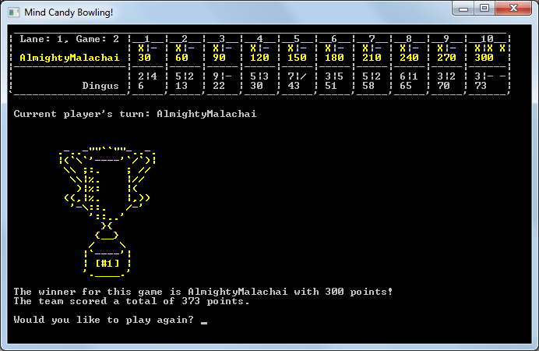

When a game has been completed, the program prompts the user to determine whether to run another game or not. If yes, then the program clears away the previous game data and returns to the player selection screen to accept a new team of 1-6 players. Otherwise, the bowling session is over and the program closes itself.

# 3 Unit Testing

In order to ensure the accuracy and reliability of this program, a number of unit tests were run to compare the expected output with that produced by the program when given the same input data. The values below are the logs of this data comparison:

|  |  |  |  |  |
| --- | --- | --- | --- | --- |
| Test | Input Data | Expected Score | Program Score | Success? |
| Average scores | 2,4 | 3,6 | 4,1 | 6 | 15 | 20 | 6 | 15 | 20 |  |
| Spare | 7,3 | 4,3 | 4,2 | 14 | 21 | 27 | 14 | 21 | 27 |  |
| Strike | 10 | 6,3 | 2,5 | 19 | 28 | 35 | 19 | 28 | 35 |  |
| Multiple spares | 7,3 | 6,4 | 8,2 | 4,2 | 16 | 34 | 48 | 54 | 16 | 34 | 48 | 54 |  |
| Multiple strikes | 10 | 10 | 10 | 3, 4 | 30 | 53 | 70 | 77 | 30 | 53 | 70 | 77 |  |
| Strike and spare | 10 | 6,4 | 5,2 | 20 | 35 | 42 | 20 | 35 | 42 |  |
| Spare and strike | 2,8 | 10 | 4,4 | 20 | 38 | 46 | 20 | 38 | 46 |  |